**Post Deployment Step**

* Setting Up User And Team for Model Driven APP User
* Setting Up Canvas App User

**Setting Up User And Team**

* Open the teams in the Environment setting
* Create Two Users in Environment Setting -->Users-->Add Users
* For Observation Capture user provide the **TFL Observation Capture** Role

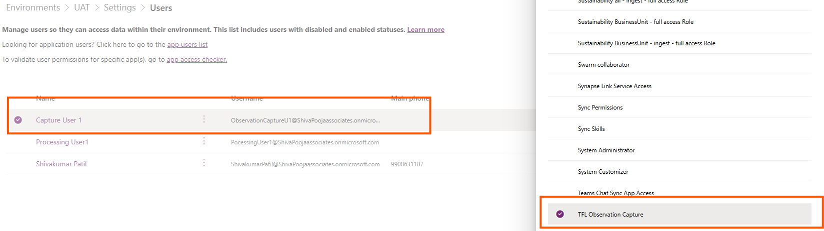

* For Observation Processing user provide the **TFL Observation processing** Role

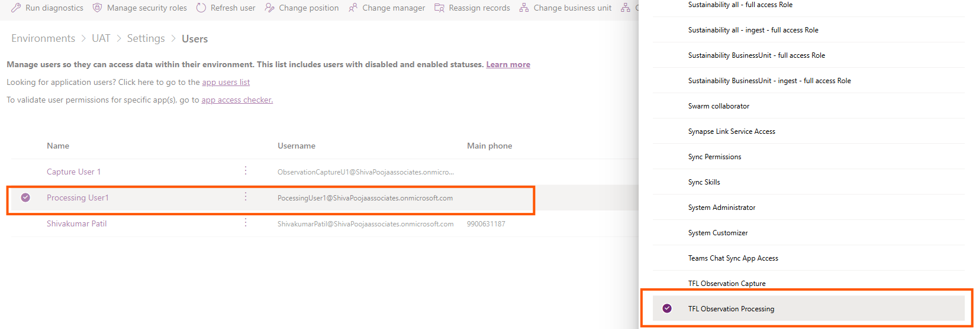

* Create a new team with Name “**Observation Processing Team” -->** after creating the team Select the **Manage Security Roles,** Select **the TFL observation Processing Role**
* Assign the Highlighted User to access the Model Driven App

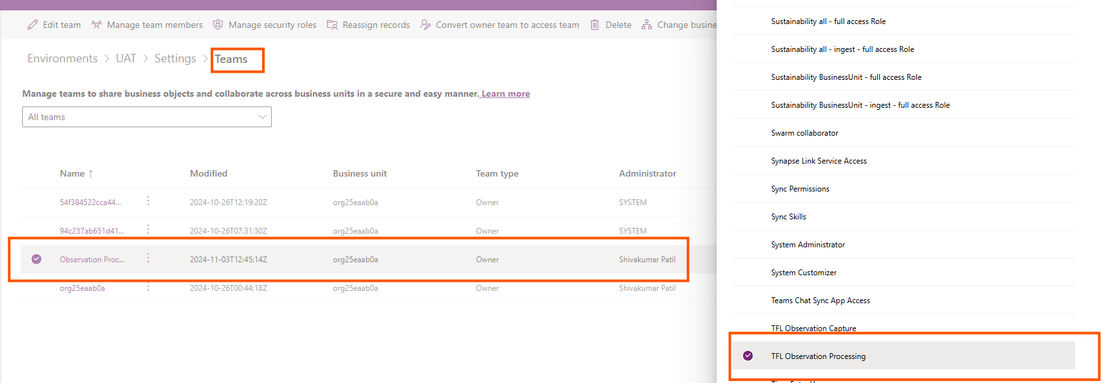

* Add Team Members

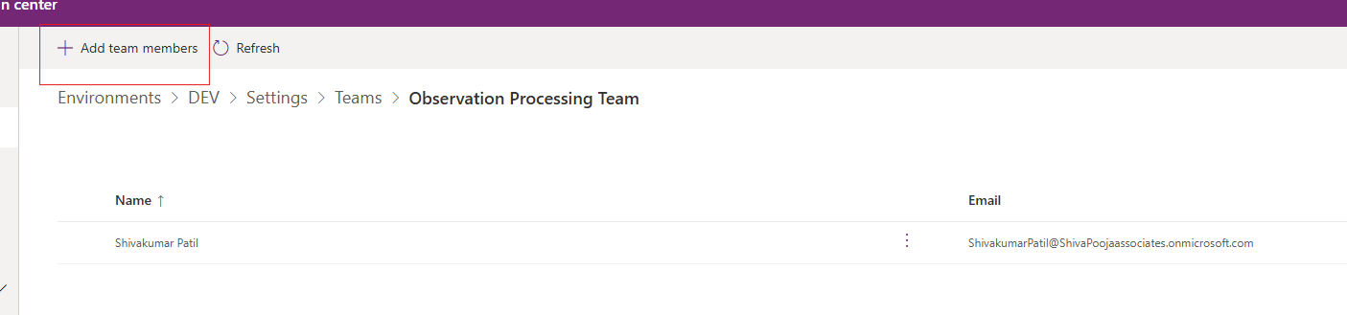

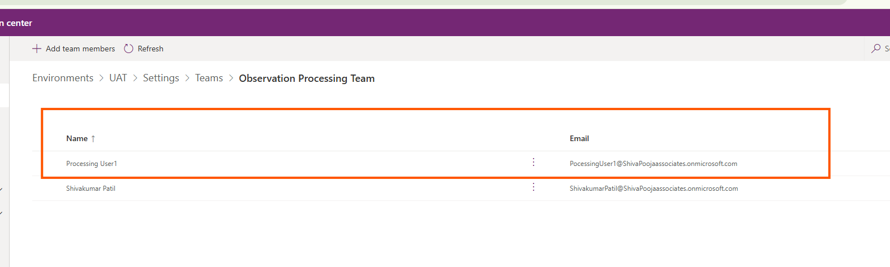

Assign the Highlighted User to access the Canvas App

**Setting Up Canvas App User**

After Solution Import Select All Apps 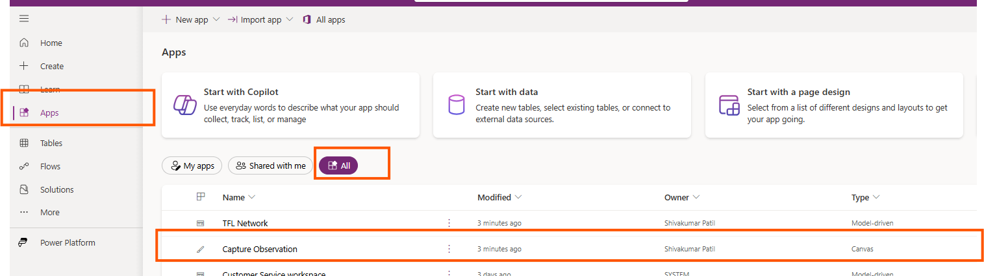

Select 3 dots --> Share --> Share

